**BIOM1010 Tutorial-Week 9**

**Part I**

1. What is the main goal of tissue engineering?

To improve the quality of life.

1. What are three main components typically required to engineer a living tissue in the laboratory?

Cells

Biomaterials

Signals

1. What is the purpose of each of these components?

Extract specific cells to culture for a specific tissue

Scaffold for cells to grow onto otherwise cells will not have structure

Changes the properties of the tissue using mechanical, electrical and biochemical means.

1. Compare and contrast the use of donor vs patient’s own cells in tissue engineering. What are the advantages/disadvantages of each?

Donor cells

* Advantages
  + More readily available
  + Healthy patient cells might not be available
  + No need for secondary surgery for the patient
* Disadvantages
  + More likely to be rejected
  + Chance of diseased tissue (improper screening)
  + Costs
  + Immunosuppressants are required if transplant is not completely compatible

**Part II**

1. Draw a schematic of the liver chip presented by Linda Griffin indicating flow inlet and outlet. What is the purpose of these and what are they trying to mimic in the body?

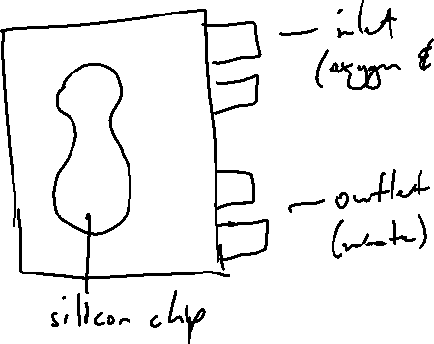

1. Why is delivery of oxygen and nutrients to cells vital? How is this done in the body?

* To keep them alive
* Capillaries are for the transfer of nutrients through diffusion
* Red blood cells transfer of oxygen via diffusion

**Part III**

1. Compare and contrast the use of natural vs synthetic scaffold materials for tissue engineering purposes? What are the advantages and disadvantages of each?

Natural scaffold – collagen

Advantage of natural scaffold

* More compatibility
* Same architecture

Disadvantage of Natural Scaffold

* Hard to extract – chemical required to decellularize scaffolds – if not properly washed then residue ends affecting cell growth
* Shelf-life – harder to maintain
* Cost